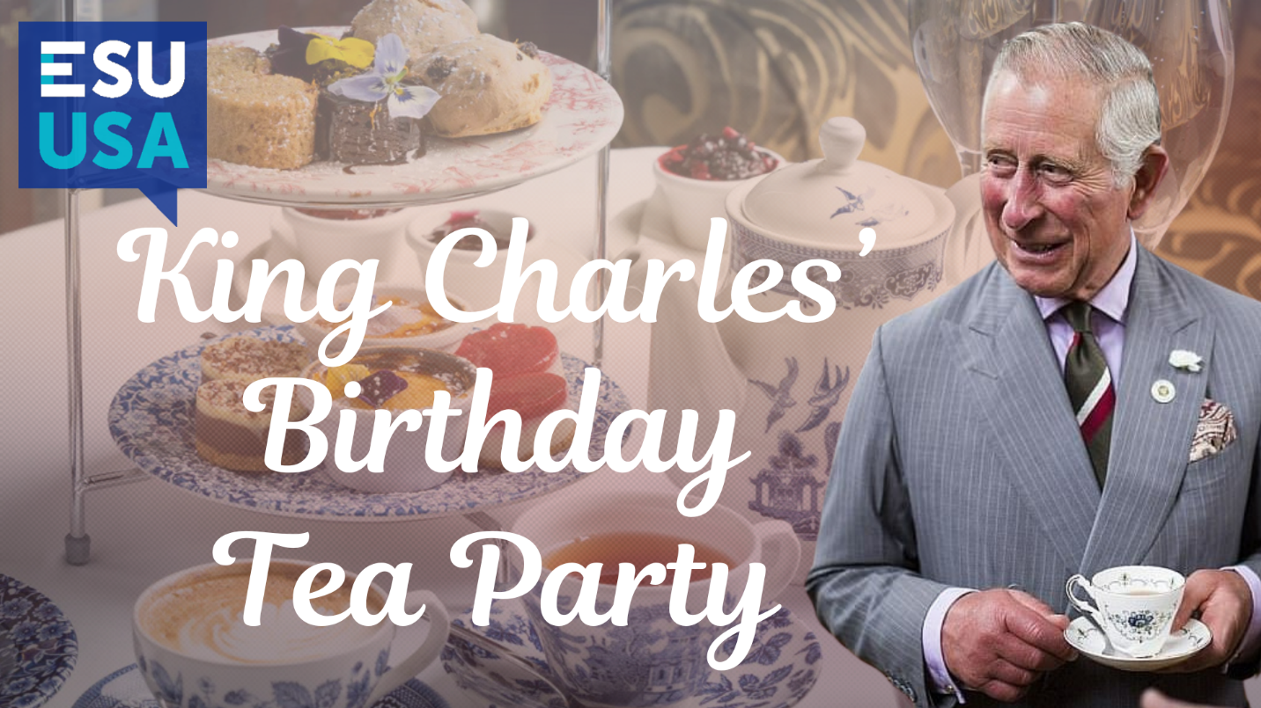
Saturday, August 9, 2025 • 10:30 am or 2:30 pm Seatings

All ESU Members and Friends of ESU are cordially invited to attend one of our biggest social gatherings of the year—A tea to celebrate King Charles III’s 76th birthday. This will be an ESU Tea Party fit for a King!

Our tea party will include a variety of tea sandwiches, sweets, Brenda’s signature scones, Mock Devonshire cream, fine fruit butter or fruit jams and premium tea. Brenda Hedrick, the owner and proprietress of Anna Marie’s Teas proudly proclaims, "This is not just any tea party--our tea experiences are delightfully extravagant!" This is a special occasion not to be missed!

This English tea will be held in the Bohnet House in Liberty, MO., which is a stately 3-story, 5,000 square foot home built in 1913. The house boasts Frank Lloyd Wright details--oak trim, 3 fireplaces and large open spaces. Its large wraparound porch and period American, French and English antique furnishings create the perfect setting for tea parties--served on a special collection of china and silver.

Our teas will include a special champagne toast to HRH King Charles’ 76th birthday and we will again have our popular Trivia Quiz as well as some special door prizes.

When: Saturday, August 9, 2025. Choose either 10:30 am or 2:30 pm seatings.

Where: Bohnet House
343 W. Liberty Dr.
Liberty, MO.
Directions and map: Click here

Tickets: $39 per person. All-inclusive, including taxes and gratuities. Tickets will go on sale beginning April 1. Check back on our website on April 1 for details to purchase tickets at www.esuus.org/kansascity.

Friends and Guests: We welcome friends and guests so please bring your friends. Our popular ESU Teas have sold out the last ten years and we encourage you to purchase your tickets as soon as possible so you won’t be disappointed.

Parking: Parking is limited around Bohnet House. Please carpool where possible. If anyone wants to use their car to carpool to reduce the number of cars, let us know and we’ll pass along information so members can contact the carpool drivers to make pick up arrangements.

Questions? Contact Ben Martin at (816) 522-8387.

